Database design

I will need 3 tables for this database:
doctor
patient
appointment

a doctor can have many patients but a patient can only have one doctor and a patient can have many appointments but there can only be one patient at those appointments

my database will look like this:

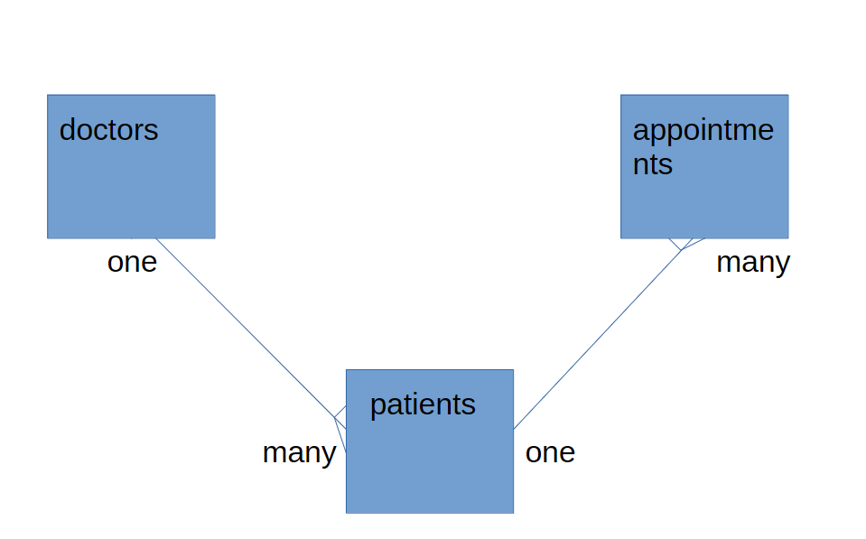
I have designed it this way because many to many relationships are not possible so you have to create a link table if you want to link two many tables. In this case I have used the patient as the link as there can only ever be one patient with a doctor and a set of appointments can only have one patient.

This is how my database looks in reality.
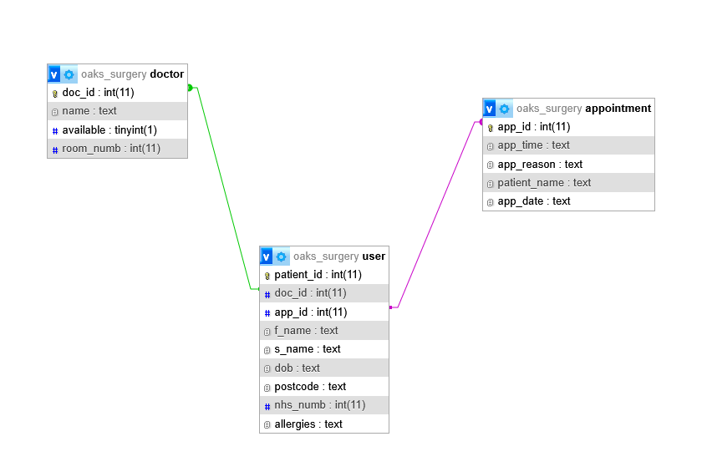

I have now made changes to my database as it didn’t function the way I intended. When trying to add a new user errors occurred due to doctor id and appointment id not being incremented which made sense after rethinking it. I have now made a completely separate link table that only stores the id’s and that’s it. More information you might want to capture about the link can also be stored here. I then added an audit table to log when new users are created, logged in and signed out. This is the new table to reflect

New link table:

